SMART E-COMMERCE CHECKOUT WORKFLOW
Cloud Computing — MCA Assignment | Version 1.0 | March 2026

PART 1: USER DOCUMENTATION
1. What is This System?
The Smart E-Commerce Checkout Workflow is a backend system that simulates how a real online shopping platform like Amazon or Flipkart handles the checkout process — from adding items to your cart, applying discount codes, processing payments, and updating stock — all automatically behind the scenes.
This system has no UI (no website or app to click on). Everything is done through API calls using a tool called Postman, which acts as the "customer" sending requests to the system.

2. What Can This System Do?
- Add products to a shopping cart
- Check if items are available in stock before adding
- Apply discount coupon codes to reduce the total price
- Process payments and save transaction records
- Automatically reduce stock after a successful purchase
- Send real-time purchase notifications through a messaging system (RabbitMQ)

3. The Shopping Flow
Step 1 — Add to Cart: Select a product and quantity. The system checks stock availability.
Step 2 — Apply Discount: Enter a coupon code like NEWYEAR. The system calculates savings.
Step 3 — Pay: Submit payment. The system processes it and applies discount automatically.
Step 4 — Inventory Update: Stock count reduces automatically after successful payment.
Step 5 — Confirmation: A payment event is published so other systems are notified.

4. Available Products
ID | Product | Price | Stock
1 | Laptop | ₹50,000 | 10 units
2 | Phone | ₹15,000 | 25 units
3 | Headphones | ₹2,000 | 50 units

5. Discount Codes
Coupon Code | Discount | Example
NEWYEAR | 10% off | ₹10,000 off on ₹1,00,000 order
SAVE20 | 20% off | ₹20,000 off on ₹1,00,000 order
FLAT50 | 50% off | ₹50,000 off on ₹1,00,000 order

6. How to Use — Step by Step (Postman Guide)
Step 1 — View All Products
- Method: GET
- URL: http://localhost:5001/inventory
- Click Send
- You will see all products with price and stock
Step 2 — Add Item to Cart
- Method: POST
- URL: http://localhost:5002/cart
- Body → raw → JSON:
{
"product_id": 1,
"quantity": 2
}
- Expected response: "Item added to cart" with product name and price
Step 3 — Apply a Discount Code
- Method: POST
- URL: http://localhost:5003/discount
- Body → raw → JSON:
{
"code": "NEWYEAR",
"original_price": 100000
}
- Expected response: Shows discount amount and final price
Step 4 — Process Payment
- Method: POST
- URL: http://localhost:5004/payment
- Body → raw → JSON:
{
"product_id": 1,
"quantity": 2,
"discount_code": "NEWYEAR"
}
- Expected response: "Payment successful" with final amount charged
- This automatically updates stock and sends a RabbitMQ notification
Step 5 — Verify Stock Updated
- Method: GET
- URL: http://localhost:5001/inventory/1
- Quantity should have reduced by the amount purchased

7. System Addresses
Service | URL | Purpose
Inventory Service | http://localhost:5001 | View and manage products
Cart Service | http://localhost:5002 | Add items to cart
Discount Service | http://localhost:5003 | Apply coupon codes
Payment Service | http://localhost:5004 | Process payments
RabbitMQ Dashboard | http://localhost:15672 | View message queue (guest/guest)

PART 2: DEVELOPER DOCUMENTATION
1. System Architecture
This system is built using a microservices architecture. Each service is an independent Flask application running in its own Docker container, communicating with others over a shared Docker network called ecommerce-net.
Architecture Pattern: Microservices with synchronous REST APIs and asynchronous messaging via RabbitMQ.
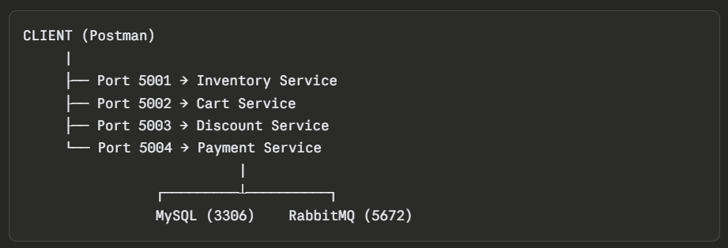

2. Technology Stack
Component | Technology | Purpose
Microservices | Python + Flask | REST API framework
Database | MySQL 8.0 | Persistent storage
Message Broker | RabbitMQ 3 | Async event publishing
Containerization | Docker | Isolated service containers
Networking | Docker Bridge Network | Inter-service communication
API Testing | Postman | Manual testing and demo

3. Project Structure
ecommerce/
├── db-init/
│ └── init.sql ← Database schema and seed data
├── inventory-service/
│ ├── app.py ← Flask app with inventory APIs
│ ├── requirements.txt
│ └── Dockerfile
├── cart-service/
│ ├── app.py ← Flask app with cart APIs
│ ├── requirements.txt
│ └── Dockerfile
├── discount-service/
│ ├── app.py ← Serverless-style discount logic
│ ├── requirements.txt
│ └── Dockerfile
└── payment-service/
├── app.py ← Payment processor + RabbitMQ publisher
├── requirements.txt ← Includes pika + requests
└── Dockerfile

4. Database Schema
inventory table
Column | Type | Description
id | INT AUTO_INCREMENT PK | Unique product ID
name | VARCHAR(255) NOT NULL | Product name
price | DECIMAL(10,2) NOT NULL | Price in INR
quantity | INT NOT NULL | Available stock

cart table
Column | Type | Description
id | INT AUTO_INCREMENT PK | Cart item ID
product_id | INT NOT NULL | Reference to inventory
product_name | VARCHAR(255) | Snapshot of product name
quantity | INT NOT NULL | Quantity in cart
price | DECIMAL(10,2) | Unit price at time of adding

payments table
Column | Type | Description
id | INT AUTO_INCREMENT PK | Transaction ID
product_id | INT | Product purchased
product_name | VARCHAR(255) | Name of item
quantity | INT | Quantity purchased
original_price | DECIMAL(10,2) | Price before discount
discount_applied | DECIMAL(10,2) | Discount amount deducted
final_amount | DECIMAL(10,2) | Amount charged
status | VARCHAR(50) | Default: 'success'
created_at | TIMESTAMP | Auto: current time

5. API Reference
Inventory Service (Port 5001)
Method | Endpoint | Response | Description
POST | /inventory | 201 Created | Add new product
GET | /inventory | 200 OK | Get all products
GET | /inventory/<id> | 200 / 404 | Get specific product
PUT | /inventory/<id> | 200 / 400 | Reduce stock after purchase

Cart Service (Port 5002)
Method | Endpoint | Response | Description
POST | /cart | 201 Created | Add item (validates stock first)
GET | /cart | 200 OK | View cart with total

Discount Service (Port 5003)
Method | Endpoint | Response | Description
POST | /discount | 200 OK | Apply coupon, return final price

Payment Service (Port 5004)
Method | Endpoint | Response | Description
POST | /payment | 200 OK | Process payment, update inventory, publish RabbitMQ event

6. Service Communication Flow
When POST /payment is called, this sequence happens automatically:
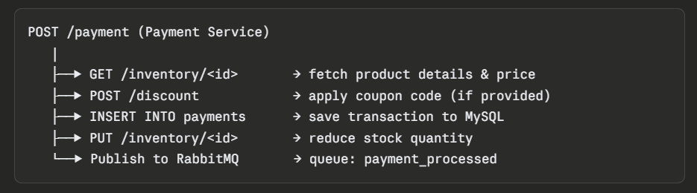
7. RabbitMQ Message Format
After every successful payment, this JSON is published to the payment_processed queue:
{
"product_id": 1,
"product_name": "Laptop",
"quantity": 2,
"original_price": 100000.0,
"discount_applied": 10000.0,
"final_amount": 90000.0,
"status": "success"
}

Verify at: http://localhost:15672 → Queues tab → payment_processed

8. Docker Setup Commands
# Pull images
docker pull mysql:8.0
docker pull rabbitmq:3-management

# Create network
docker network create ecommerce-net

# Start MySQL
docker run -d --name mysql-db --network ecommerce-net \
-e MYSQL_ROOT_PASSWORD=root123 \
-e MYSQL_DATABASE=ecommerce \
-p 3306:3306 mysql:8.0

# Start RabbitMQ
docker run -d --name rabbitmq --network ecommerce-net \
-p 5672:5672 -p 15672:15672 rabbitmq:3-management

# Initialize database
docker exec -i mysql-db mysql -uroot -proot123 < db-init/init.sql

# Build and run each service
docker build -t inventory-service ./inventory-service
docker run -d --name inventory --network ecommerce-net -p 5001:5001 inventory-service

docker build -t cart-service ./cart-service
docker run -d --name cart --network ecommerce-net -p 5002:5002 cart-service

docker build -t discount-service ./discount-service
docker run -d --name discount --network ecommerce-net -p 5003:5003 discount-service

docker build -t payment-service ./payment-service
docker run -d --name payment --network ecommerce-net -p 5004:5004 payment-service

9. Dockerfile Pattern (same for all services)
FROM python:3.11-slim
WORKDIR /app
COPY requirements.txt .
RUN pip install -r requirements.txt
COPY app.py .
CMD ["python", "app.py"]\

10. Troubleshooting
Problem | Solution
Container not starting | Run: docker logs <container-name>
SyntaxError in app.py | Remove markdown backticks (```) from the file
Port already in use | Run: docker rm <name> then re-run docker run
Cannot connect to MySQL | Wait 15 seconds after starting mysql-db, then retry
RabbitMQ connection failed | Check docker ps — ensure rabbitmq container is running
requirements.txt not found | Ensure file is in same folder as Dockerfile

11. Assignment Requirements Checklist
Requirement | Status
Backend Database (inventory, cart, payments tables) | ✅ Done
Inventory Service — POST, GET, GET ALL, PUT | ✅ Done
Cart Service — POST and GET | ✅ Done
Payment with Discount (NEWYEAR code) | ✅ Done
Payment without Discount | ✅ Done
Publish payment_processed event to RabbitMQ | ✅ Done
Inventory updates persist in MySQL | ✅ Done
Checkout via Postman (Cart→Discount→Payment) | ✅ Done
Synchronous REST + Async messaging demonstrated | ✅ Done
Real-world workflow mimicking Amazon/Flipkart | ✅ Done

